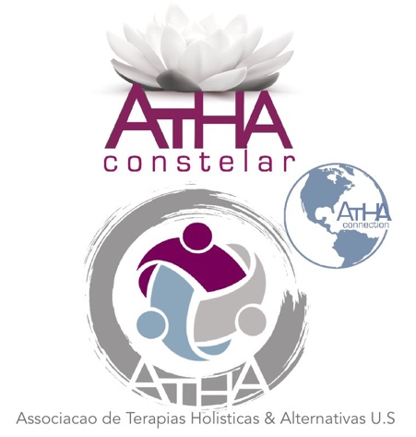 6965, Piazza Grande Ave. #107 – Orlando – FL 32835 – 321-368-2218

Systemic Family Constellations

Of course, existence is infinite, but we rationally know very little about it. What happens and shows itself on the surface is that we are born and die within this life, a very complex dynamic for us to understand still. What does it really mean to be human and have this existence here? What is the purpose of it?
Since our birth we belong to a family system, which, for integrating ancestors and their histories, as well as our own universe, was named "Systemic Family Constellation", also known as Systemic Constellation or Family Constellation. Just as they operate in our well-know Universe, the energy fields of memories and repetitions must remain in balance and harmony. Naturally, when this motion is altered, through abandonment, an absence or an exclusion, all this balance is broken. Since everything in the Universe works perfectly

and every motion has a response, this rupture also generates imbalances in the future generations to come, like the pebble that is thrown into the water generating waves. The great mystery of life calls for everything to be reinstated and harmonized, because to belong is the first law of the Universe to be followed.
Naturally, if our parents and the parents of our parents do not look at this imbalance, life itself will try ( tirelessly ) to readjust itself within that incomplete reality where, that forgotten death, the not accepted or faced losses, the failures and the phobias, or even the diseases that happen and repeat themselves, will try to maintain our current life history, with everyone who is connected to it, within a balance compensation motion.
In the Systemic Constellation Therapy, we will find the answers and adjustments for the imbalances, difficulties and repetitive patterns happening in our lives systematically.
We will also relearn that exactly as it happens in the Universe, there is an established order, and when any of these orders are broken, everything will be out of harmony and life itself will begin to bring out what needs to be restored. This therapy is so profound that it changes not only the person who is being constellated, but also his entire family network, with great positive results. Any area of ​​life can be worked on, without distinction, such as health, relationship, infertility, anxiety, traumas, abuse and so on.
The meetings may happen in groups and/or individually.

Contact us: 321-368-2218 or athaholistica@gmail.com

